Book Donations | March 1 2023 - current | NEHS- Towson High School’s chapter of the National English Honor Society hosted a book drive to benefit the Maryland Book Bank. This initiative keeps books from being thrown away or recycled and benefits the larger community. | See below for a picture
RECYCLING EVIDENCE
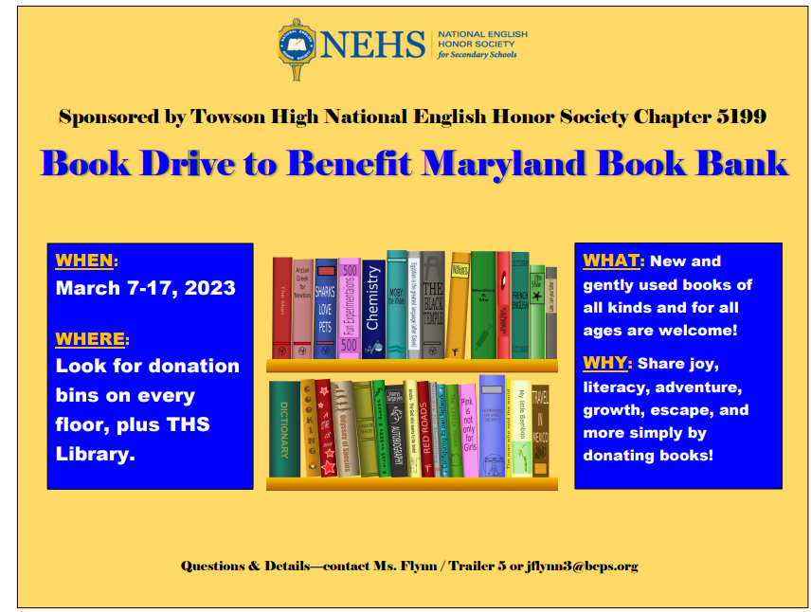
NEHS Book Drive
